Space Allocation and Assignment Guidelines
Definitions, Process and Standards
At UC Merced, most space is allocated to Schools, Divisions, Departments, and Programs by the Chancellor based on analysis and recommendations from the Office of Space, Capital Strategies & Real Estate. Within a space allocation, particular spaces are assigned to individuals by the Department Chair or Program Director, in consultation with the appropriate Division Vice Chancellor or Dean’s Office. The initial path of appeal for space assignment decisions is to the Department Chair, Dean or Vice Chancellor. The final path of appeal is through the Executive Director of SCSRE to the Chancellor.

Space Allocation and Assignment Steps:
- The 2020 Project and Backfill Space Allocation Plan, approved December 2018, outlined the conceptual space allocation plan through 2025 for the UC Merced campus. Should a division, school, department, or program wish to request additional space beyond the 2018 space allocation plan, they should submit a space request form via the space request process to the Office of Space, Capital Planning and Real Estate. The Chancellor reserves the right to make space decisions outside of the comprehensive plan.

- The SCSRE office develops a recommended response to each space request, that is evaluated and approved or rejected by the Chancellor. If approved, the requestor is notified of the response; if rejected a new recommendation is developed until approval by the Chancellor is garnered.

- The Department Chair (or Program Director), in consultation with the Dean or Vice Chancellor, may assign a specific area within the allocated space to a particular individual (e.g., faculty, post-docs) and/or function. Department Chairs should inform their department specialists of all space assignments. Department specialists and Program Directors will notify the appropriate central space management staff (SCSRE and Planning, Design & Construction (PD&C)) of all space assignments.

- Any future change(s) to space assignments within space that has already been allocated should be discussed first with the relevant Dean or Vice Chancellor. Department Chairs should inform their department specialists of all modifications or changes to space assignments. Department specialists and Program Directors will notify the appropriate central space management staff (SCSRE and PD&C) of all modifications or changes to space assignments.

- The Department Chair or Program Director should discuss requests for modifications to furniture and/or space with the relevant Dean or Vice Chancellor. Once there is agreement on the scope of, and funding for, modifications please complete a Project Request Form and submit the signed form to SCSRE in March or September. The group making the request is responsible for identifying the source(s) of funding, including costs for modifications and relocation costs associated with moving existing occupants/functions of the space.
Space Issues Outside of the Regular Process:
- Extramural Grants – Should a faculty member wish to apply for a grant that has specific space requirements that are above and beyond the space already assigned to them, they should contact the Dean of their School and the Executive Director of SCSRE to discuss the space requirements of the grant, prior to applying for the grant.
- Faculty New Hire Searches – Similarly prior to launching a faculty new hire search, the Chair of the Search Committee is encouraged to reach out to the relevant Dean, Department Chair or the Executive Director of SCSRE to confirm that there is appropriate space available for the faculty member that is being sought in the discipline in which they are based.

- Conflicts of Interest – Should a person believe that a particular space assignment shows evidence of a conflict of interest, they are encouraged to speak directly with the Executive Director of SCSRE or their School Dean or Division Vice Chancellor.

- The Executive Director of SCSRE, the Interim CFO and Provost will soon begin to explore methodologies and metrics for the evaluation of efficient use of space including the possibility of space chargebacks and metrics for the reallocation of space due to inefficient use. There will be opportunities for community participation in these discussions.

GUIDELINES FOR SPECIFIC ASSIGNMENT BY POSITION & SPACE TYPE
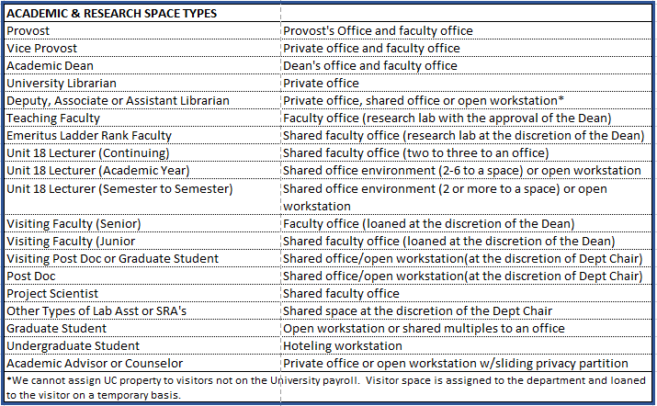

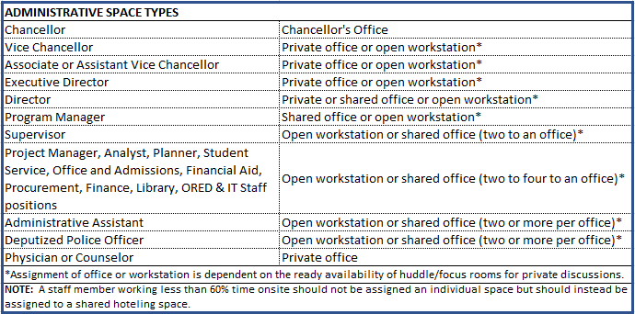
DISCLAIMER: This document does not purport to include a complete list of positions or space types. It is meant to provide representative direction to Program Directors, Dean’s, Department Chairs and Division Heads.

